**How to Log into HISD HUB (itsLearning)**

2. Open the app and search for “Golfcrest”.

1. Search for the “itslearning” app in the Apple App Store.

Download and install.

3. Click “External sign in” and then click “Houston ISD Account” .

4. Login with students login information:

Student\s###### <- This is their student ID number

MMDDYYYY <-password is the student’s birthday in numbers including the year (ex. 01012020)

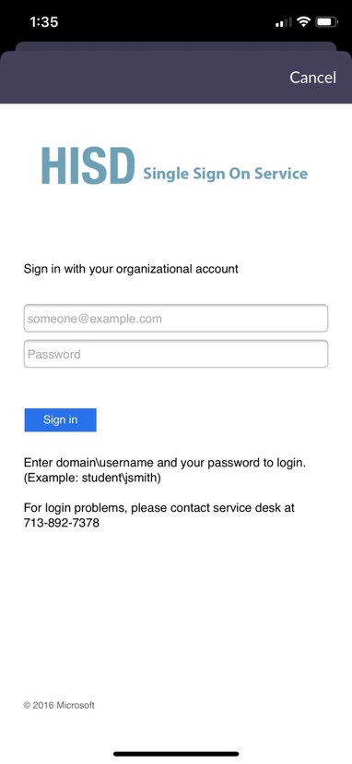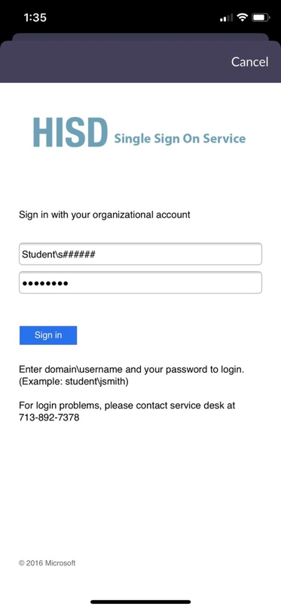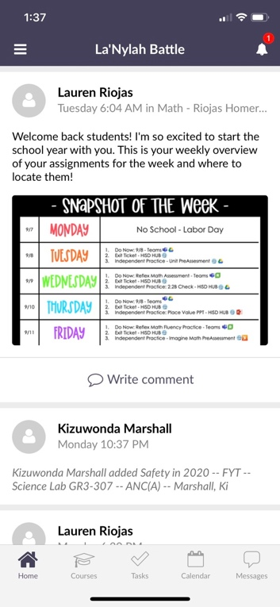

This is the home page. Here you have access to Courses, Tasks, Calendar and Messages.

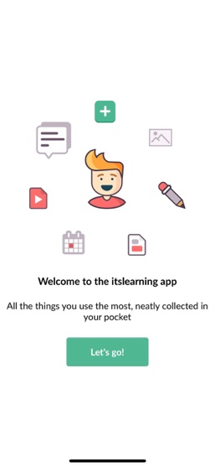

**Courses**

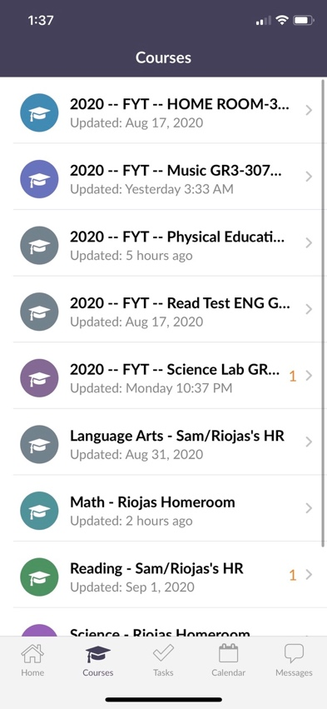

2. Here is a list of all courses that your student is enrolled in. Select the course your student will need to work asynchronously in.

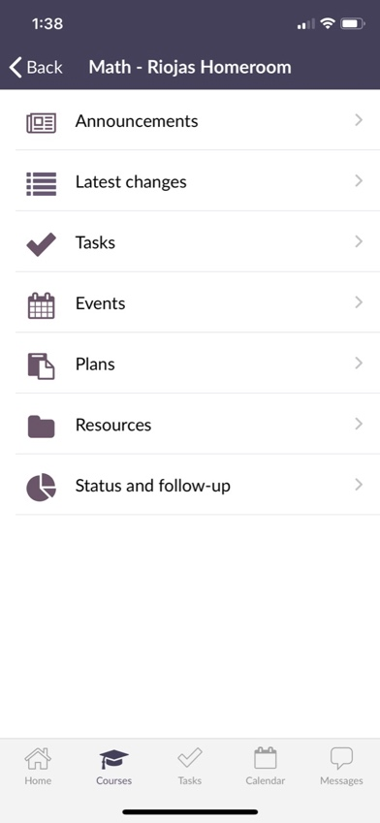

3. Depending on the teacher’s set up – assignments can be found in “Tasks”, “Plans” or “Resources”.

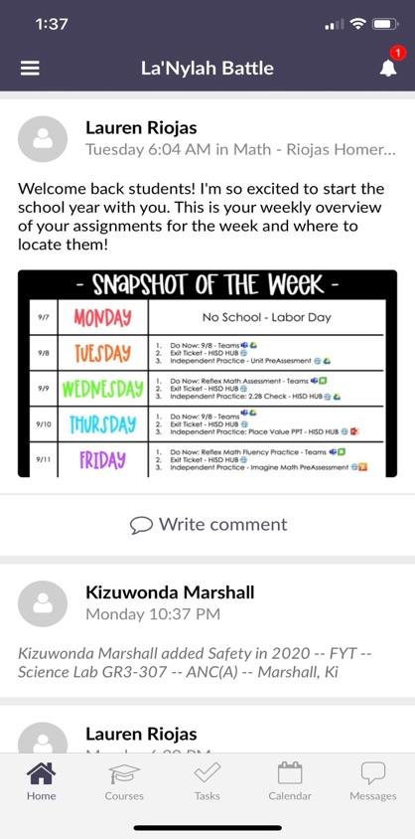

1. Use the tool bar to select courses.

**Tasks**

These are assignments due the current week and that are upcoming.

This icon means Homework

This will show assignments overdue.



1. Use the tool bar to select “Tasks”.

**Digital Resources - Clever**

Clever is the access point for all digital textbooks and digital classroom resources. This is a single sign-on platform so it should automatically log your student into the program or recourses. **Please note: Some resources are only available through a computer web browser or through a phone app. Some resources may not be available through the mobile web browsers.**

4. Login with students login information:

Student\s###### <- This is their student ID number

MMDDYYYY <-password is the student’s birthday in numbers including the year (ex. 01012020)

2. Clever will open in your internet browser. Click “Login with Active Directory” Use your student’s HISD Login.

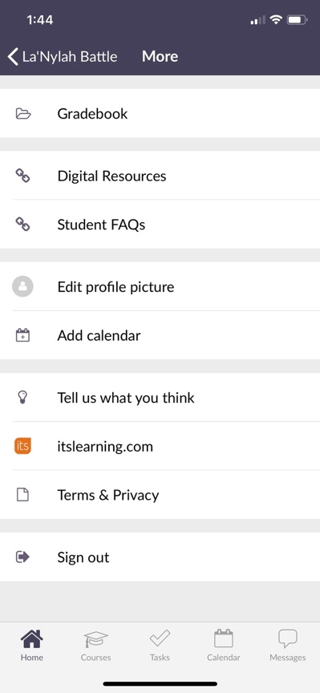

x

2. Tap on Digital Resourses.



1. Click on the menu bars in the top left corner.